**Hands On Lab 2**

**Java Nio Pipe**

In Java NIO pipe is a component which is used to write and read data between two threads. Pipe mainly consists of two channels which are responsible for data propagation.

Among two constituent channels one is called as Sink channel which is mainly for writing data and other is Source channel whose main purpose is to read data from Sink channel.

Data synchronization is kept in order during data writing and reading as it must be ensured that data must be read in a same order in which it is written to the Pipe.

It must kept in notice that it is a unidirectional flow of data in Pipe i.e data is written in Sink channel only and could only be read from Source channel.

In Java NIO pipe is defined as a abstract class with mainly three methods out of which two are abstract.

## Methods of Pipe class

* **open()** − This method is used get an instance of Pipe or we can say pipe is created by calling out this method.
* **sink()** − This method returns the Pipe's sink channel which is used to write data by calling its write method.
* **source()** − This method returns the Pipe's source channel which is used to read data by calling its read method.

1. **Create a new Project**

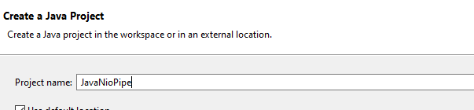

1. **Create a new class as below**



1. **Code the following implementation of Java NIO pipe.**

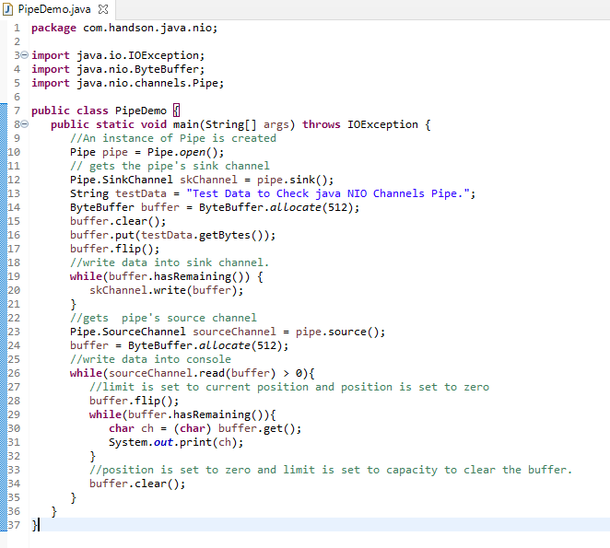

1. **Run the above program.**



